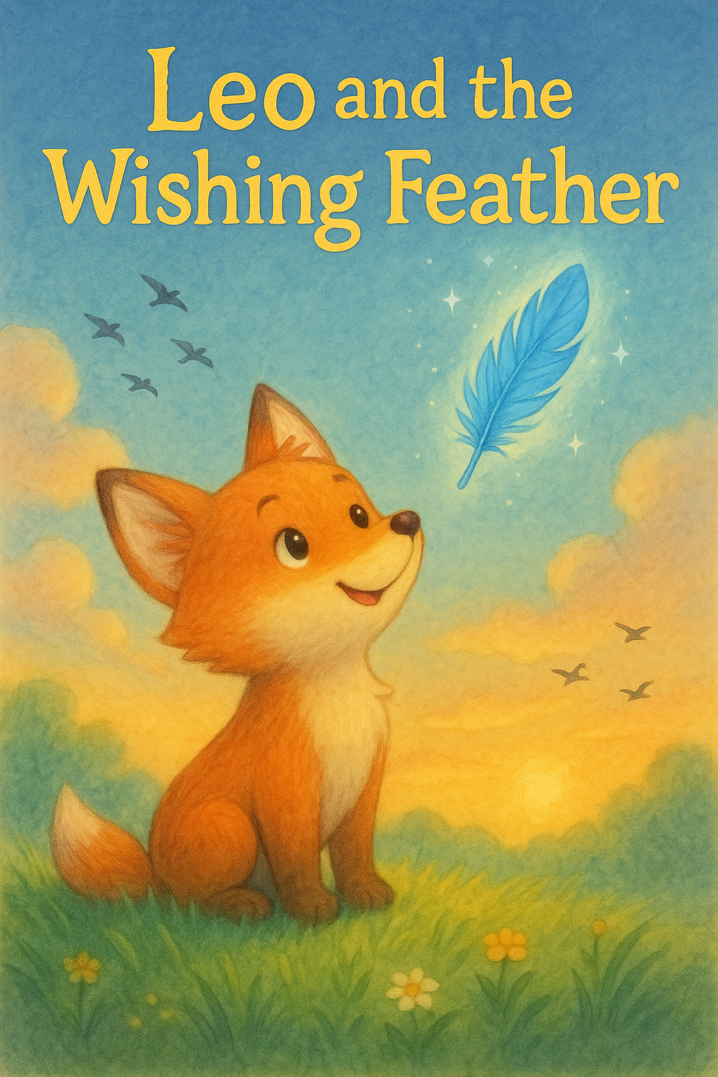

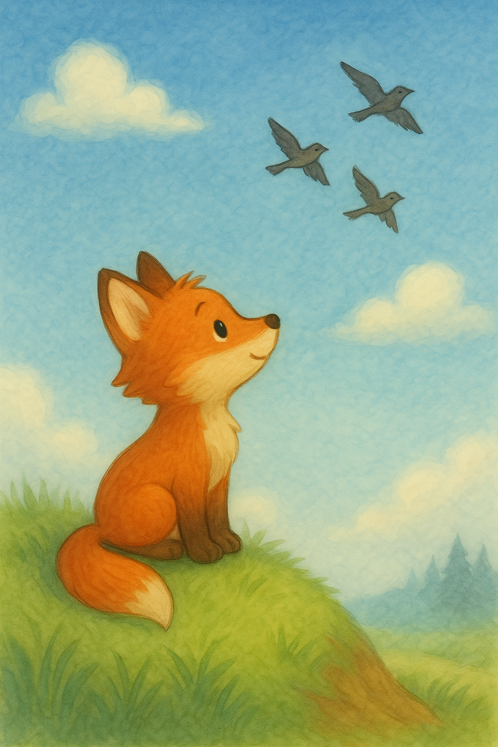

Leo was a little fox who loved to chase butterflies and roll in the grass. But what he wanted most in the world was to fly like the birds.

Every morning, he’d watch the robins flap and soar above the forest trees, and he’d sigh, “If only I had wings!”

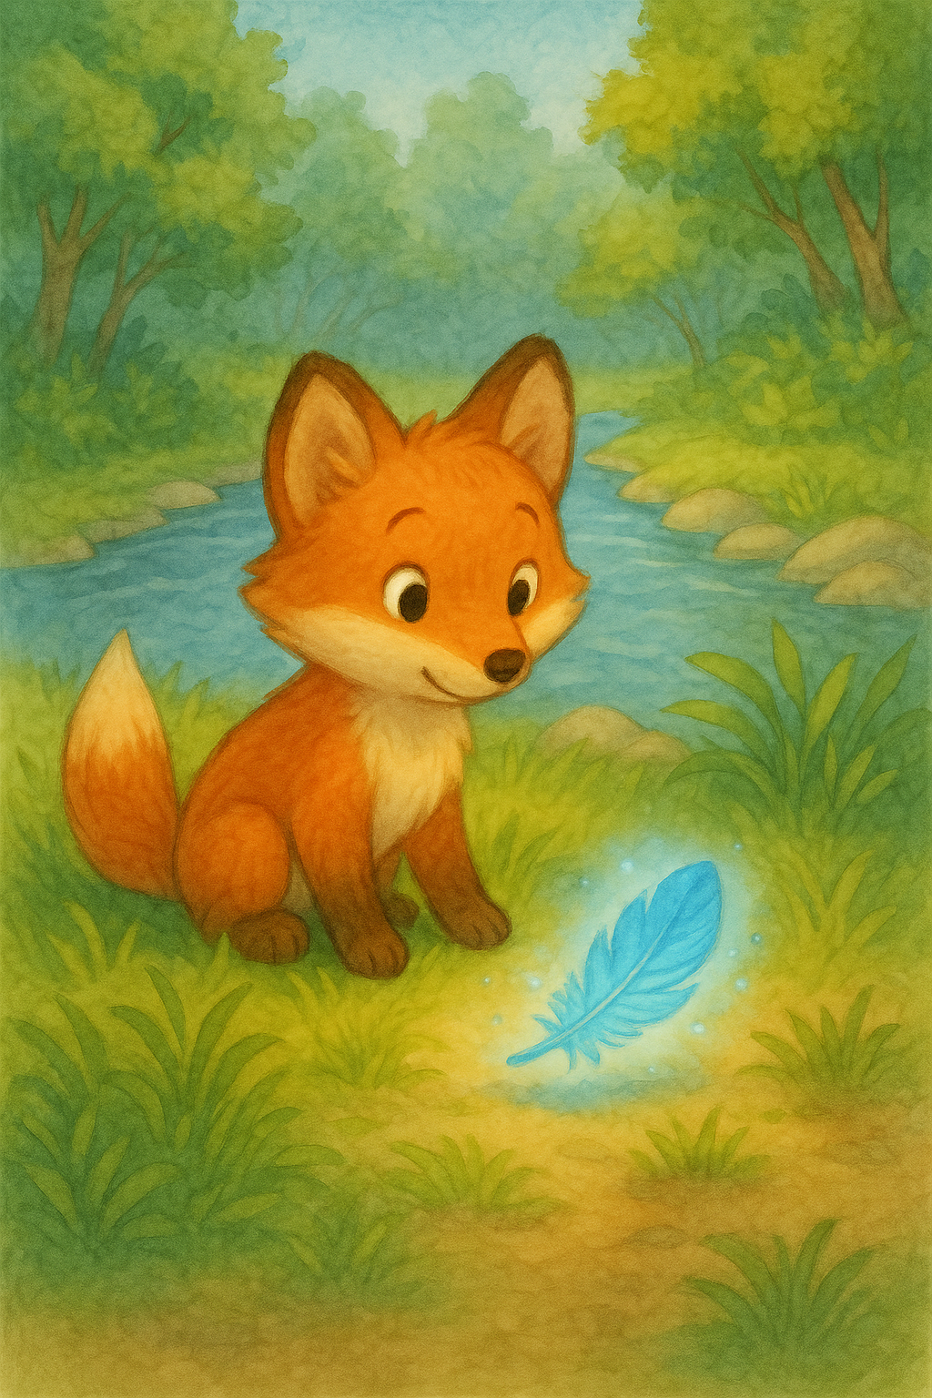

A small voice whispered from the wind, “This is a wishing feather. Make a wish from your heart.”

Leo closed his eyes and whispered,   
“I wish to fly, even just once.”

One day, while walking near the river, Leo found a bright blue feather shimmering in the sunlight. It glowed gently, like it had a secret.

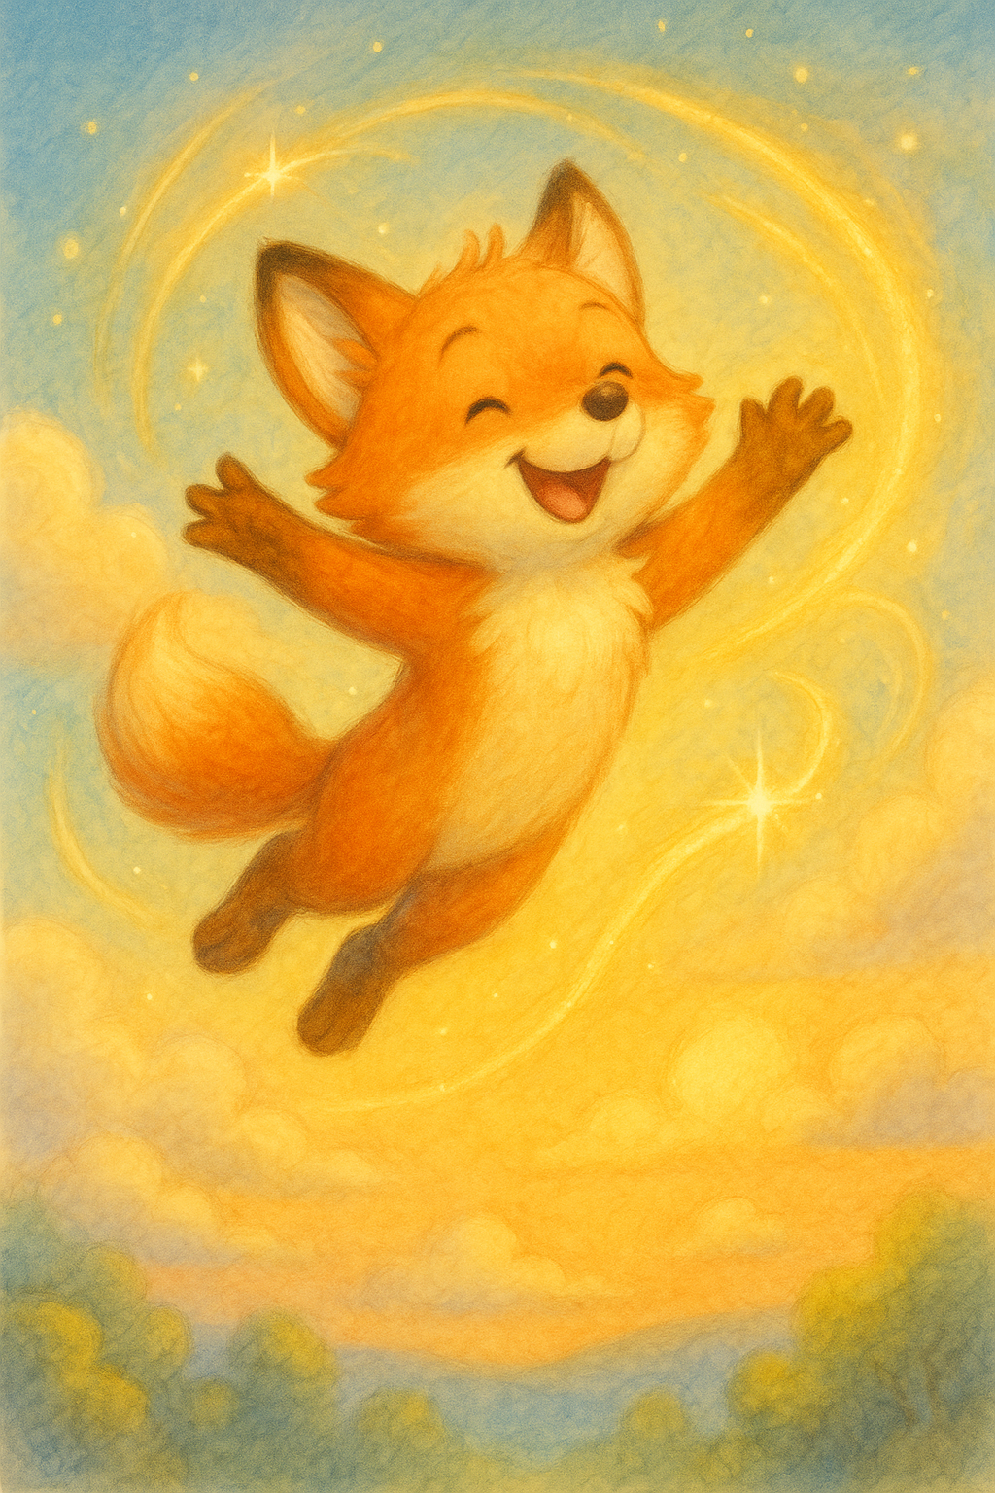

He laughed and flipped and fluttered,   
just like a bird.

Suddenly, the feather spun around him, faster and faster, until it lifted Leo into the sky!   
He zoomed past clouds and dipped through sunbeams, his fur glowing golden in the light.

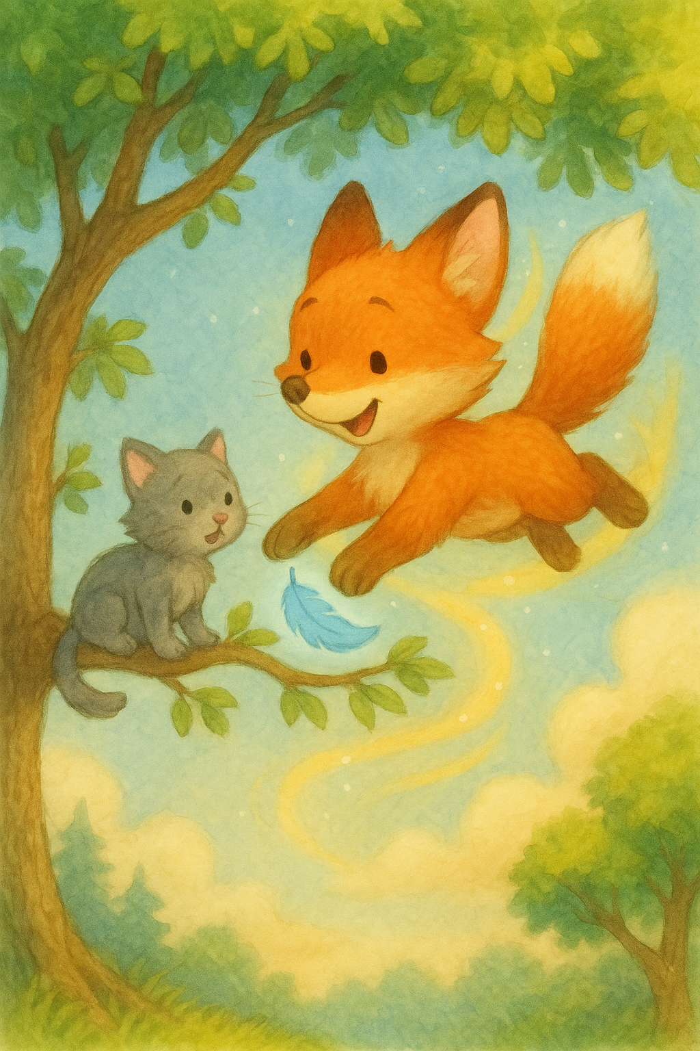

Leo swooped down and gently   
grabbed a branch with his teeth,   
nudging Mia toward safety.

But then he heard a soft meow from below.   
It was Mia the kitten, stuck at the top of a tree, too scared to come down

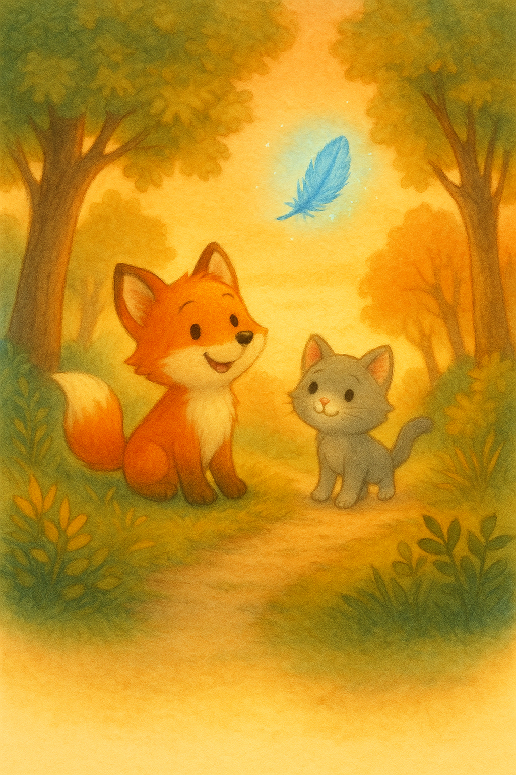

The End.

From that day on, Leo didn’t chase butterflies as much. He liked to walk with Mia and tell her stories about the day he flew. And sometimes, when the wind blew just right, the feather would shimmer again.

“You saved me!” Mia purred. Just as Leo’s paws touched the ground, the feather floated down beside him. Its glow faded. Leo smiled. “Even if I never fly again, I used my wish to help.”